**Creating your Core Message**

*“People don’t buy what you do. They buy why you do it.”*

- Simon Sinek

ACTION ITEM: Watch Simon Sinek’s Ted talk, “How Great Leaders Inspire Action”

This 18 minute video will change how you think about effective communication forever. As you watch, consider your own motivations and deeply rooted beliefs that have compelled you to step up and seek election so that you can serve your community.

You have your own unique “WHY.”

Finding it and sharing it will improve your core message, because great leaders start with why.

Y

our campaign’s core message must be written down. Somewhere. By someone. If it isn’t written down, it doesn’t exist, period. Ideally, the candidate (you) will sit down and write this core message, then rewrite it until it “sings.”

Elements of your core message include;

* Your WHY
* Your values
* The central contrast between you and your opponent
* Top priorities or key issues

Inputs that inform your core message include;

* Your brand
* Tully Box

Your brand informs your core message, which must be consistent with your brand, but your brand is not, in and of itself, your core message. The world is too transparent and voters are too smart to be fooled by an inauthentic pairing of brand and message.

A Tully Box is a tool for thinking about how to communicate you and your opponent’s greatest strengths and weaknesses. This informs your core message by highlighting what you want to talk about (your strengths) and how it contrasts with your opponents weaknesses. It also can help you prepare for what your opponent may say about you – revealing insight into how to inoculate against potentially damaging attacks.

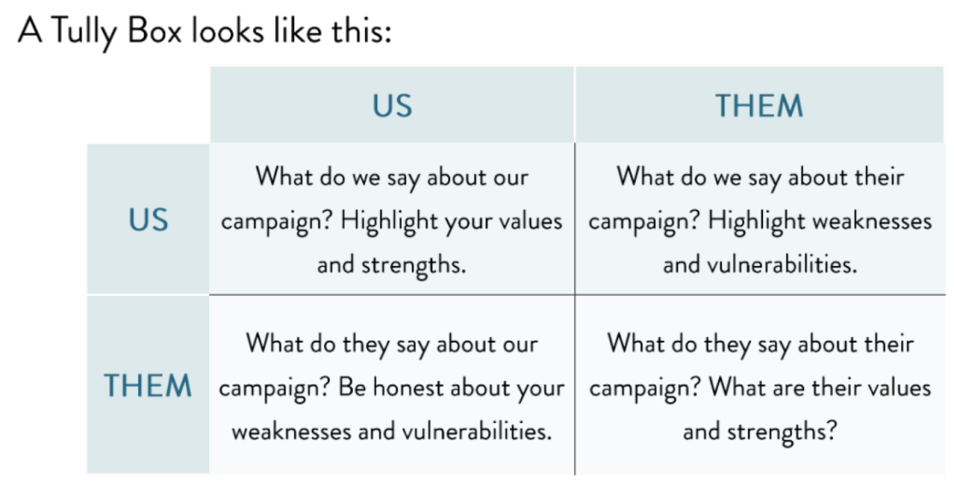

You don’t need to write a novel; quick words and ideas are fine – young, experienced, community involvement – these descriptors paint a picture of the candidate you are and the candidate your opponent will make you out to be. Start with as many descriptors as you can, but try to group them into 3-4 main points be succinct.

Completing a Tully Box can help inform your core message, as described above.

Finalizing your core message can be tough. As you work on it remember that your core message is neither your stump speech or a slogan – it is 2-4 declarative lines in a sequence that are clear, concise, contrast yourself with your opponent and connect with voters. Include your Kitchen Cabinet on this process and test your message at the doors. If the message doesn’t seem to be resonating, consider a slight adjustment, but work out the kinks sooner rather than later. A constantly changing message reflects a confused campaign – and that is NOT a perception you want to leave voters with!

**Implementing your Core Message**

Once completed, your core message should be incorporated into everything you do, remember: “Communications is everything because everything is communications!”

* At the doors
* On the phone (with donors AND voters)
* In interviews with local news
* Responding to debate/forum questions
* In your campaign mail pieces and literature

**TEST YOUR CORE MESSAGE: Have a trusted friend ask you 3-5 questions, if you can naturally incorporate your core message into each answer, you’re in great shape!**