

**Class of 2019 Training Weekend #3  
Alexandria - March 23rd & 24th**

***\**** *\*All of this information can be found on the* [*Class Member Resources webpage*](https://la.emergeamerica.org/weekend-3/)

**Schedule:**

**Friday, March 22nd**

**6 p.m. – 8 p.m. Meet the Class Reception**

The home of Maria Losavio (Class of 2018)

5826 Navaho Trail, Alexandria, LA 71301

**Saturday, March 23rd**

**8:30 a.m. – 9 a.m. Breakfast & check in**

Holiday Inn Alexandria Downtown Allen Room - 701 4th St, Alexandria, LA 71301

**9 a.m. – 6 p.m. Training Day 1: Creating a Budget, Fundraising & Cash Flow; Call Time**

*\*Lunch served at 12:30 p.m.*

Holiday Inn Alexandria Downtown Allen Room - 701 4th St, Alexandria, LA 71301

**7 p.m. – 8:30 p.m. Class Dinner**

*Location TBD – Class Social Chairs for the weekend are Dora & Fayenisha*

**Sunday, March 24th**

**8:30 a.m. – 9 a.m. Breakfast & check in**

Holiday Inn Alexandria Downtown - 701 4th St, Alexandria, LA 71301

**9 a.m. – 3 p.m. Training Day 2: Digital Ads, Media Relations, Stump Speech Practice**

*\*Lunch served at 12:30 p.m.*

Holiday Inn Alexandria Downtown Allen Room - 701 4th St, Alexandria, LA 71301

**Hotel Block Information:**

Rooms are available Friday, Saturday & Sunday nights. $98/night. You have the option to share rooms with

A fellow class member or not. Please CALL the Holiday Inn as they have not sent me a link to book online.

[***Holiday Inn Alexandria Downtown***](https://www.ihg.com/holidayinn/hotels/us/en/alexandria/alxdt/hoteldetail) ***- 701 4th St, Alexandria, LA 71301***

***Phone number: (318) 541-8333***

**Supporter Housing:**

Candy Christophe and Maria Losavio (Class of 2018) have opened their homes to the 2019 class members. They both have ample space. Please email Maria & Candy directly if you are interested in supporter housing.

***Maria: maria@losaviolawoffice.com***

***Candy: candychristophe4congress@gmail.com***

**Carpooling:**

You are encouraged to carpool with your Emerge sisters to Alexandria! Please facilitate those plans

on your own.

**Directions to Class:**The Holiday Inn in downtown Alexandria is in a great, centralized location. There is complimentary parking that is easy to find. Enter the parking lot on 4th Street. See map below.

**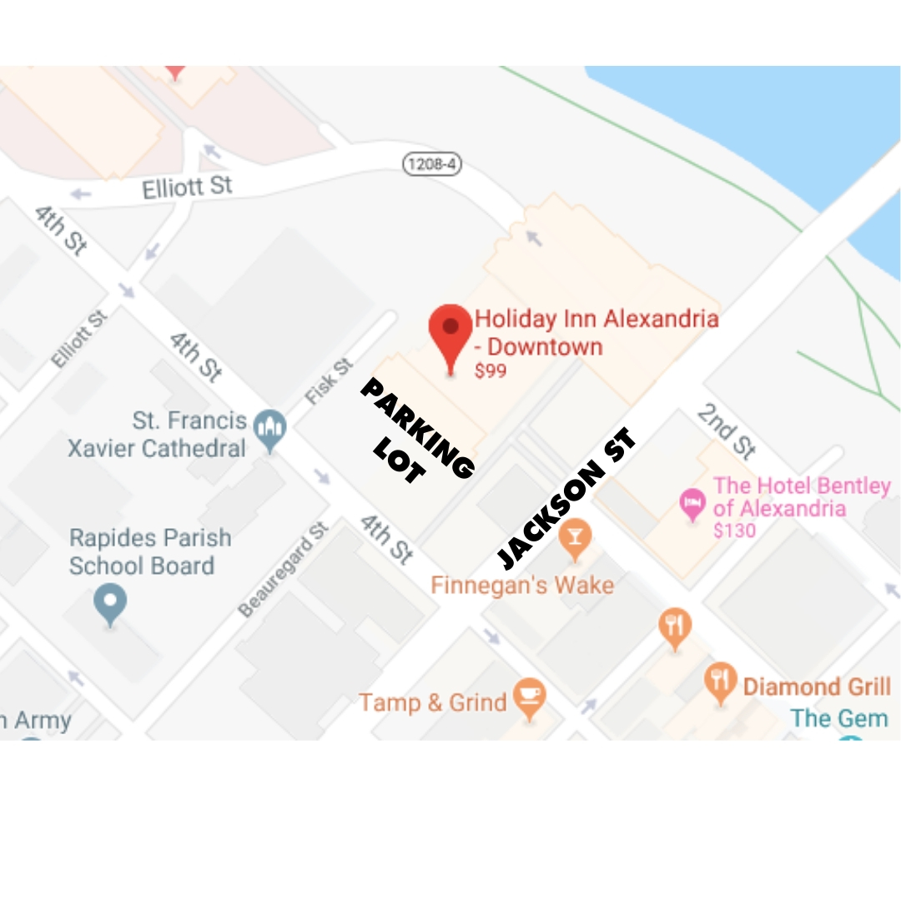  
  
Class Officers:**

* **Emcees: Megan Snider & Erica Martinez |** The Emcees are responsible for introducing all the speakers on that class day. A great way to practice a valuable skill and get to know some of our speakers!
* **Whip: Candy Christophe |** The Whips are responsible for helping the class run on time, getting classmates back from breaks, keeping speakers on time, passing out handouts, etc.
* **Social Chairs: Dora Lambert & Faye Matthews |** The Social Chairs are responsible for setting up one social event in the month before the class.

**Homework:**

1. **Campaign Nuts & Bolts |** Write up a memo outlining the strategic considerations of your campaign (what makes it different), your strategic objective(s), and the tactics you plan to utilize to achieve the strategic objectives. Send a copy to your Executive Director. *HELPFUL DOCS: 1-3*
2. **Campaign Nuts & Bolts |** Read through sample campaign plan and give feedback. *HELPFUL DOCS: 4-7*
3. **Messaging |** Test two of your messages on two different people. What were their reactions and their feedback? Discuss on Facebook Group. *HELPFUL DOCS: 8-10*
4. **Messaging |** Think about how your message would change based on who you’re running against. *HELPFUL DOCS: 11-14*
5. **Messaging |** Re-write your biography so the message you most want to convey is more apparent and send it to your Executive Director. *HELPFUL DOCS: 15*

**Prework:**

1. **Creating a Budget, Fundraising & Cash Flow |** Look at how much money was raised and spent on similar races.

* State & local candidates: [Louisiana Board of Ethics database](http://www.ethics.la.gov/CampaignFinanceSearch/).
* Federal candidates: [Federal Election Commission database](https://www.fec.gov/data/).

1. **Call Time as a Candidate |** Prepare a list of 15 people you could call and ask for money from and bring it to class. *HELPFUL DOCS: 16*
2. **Stump Speech |** Write your 2-minute stump speech and be prepared to present without notes. *HELPFUL DOCS: 17-18*
3. **Earned & Social Media |** Watch the [Emerge America “Social Media 101” webinar](https://drive.google.com/file/d/1V1NDTQlEHaHN4rw-p2FimFoaNND09u4i/view) if necessary.
4. **Earned & Social Media/Paid Media & Digital Ads |** Read the local paper for a month before class.
5. **Paid Media & Digital Ads** | Keep an eye out for political paid media and save examples.

**Attire:**

Attire for the weekend is business casual. Comfort + layers are key!

**Bring from home:**

Notebook, pens, uncompleted forms, tuition installments, homework, pre-work, your 2-minute stump speech.

**Evaluations:**

We only received 17 submissions for Weekend #1 evaluation and only 14 for Weekend #2. If we do not have full participation, we will have to move to a paper evaluation and make everyone finish before leaving on Sunday. I don’t want to do this. Please fill these out. It only takes a few minutes.

* + - Weekend #1 Evaluation: <https://form.jotform.com/90125591885161>
    - Weekend #2 Evaluation: <https://form.jotform.com/90474197412156>

**Lagniappe:**

* A reminder to read through all of the Class Member Resources online. I’ve noticed evaluations citing issues addressed at the beginning of program. For example: sodas in class. The Welcome Memo lists drinks that would always be provided and those that would not. (An alum donated snacks & soda for the Shreveport session.)
* Bookmark [the Class Webpage](https://la.emergeamerica.org/class-member-resources/) if you have not done so yet. This is where I post upcoming training information, helpful curriculum files, homework, trainer bios, and more. When in doubt or looking for anything, look here before asking me.
* Office Hours on Wednesdays. Please use this time to ask me questions or bounce ideas around.

***Every Wednesday from 12 pm - 1 p.m.***

***Call: (515) 739-1737; Access Code: 580282***

* Scheduling an urgent, private call. You can use my [Calendly](https://calendly.com/emerge-louisiana) link to schedule a 30-minute phone call with me.



**Trainer Biographies – March 23-24, 2019**

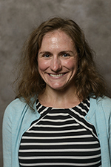**Nicole Bauer**

**Topic: Media Relations**

I am an Assistant Professor of Political Communication in the Department of Political Science & the Manship School of Mass Communication at Louisiana State University. Before coming to LSU, I was an Assistant Professor in the Political Science Department at the University of Alabama. My research examines how strategic campaign communication affects voters’ decision-making especially when voters are considering non-traditional candidates.

More specifically, my research agenda focuses on identifying the psychological underpinnings motivating political attitudes and behaviors. I focus on examining the influence of the news media, campaign strategies, and other political institutions on how voters behave. I incorporate theories and methods from psychology, public opinion, and mass communication into my research. My work has been published in Political Psychology, Political Behavior, and the​ International Journal of Press/Politics among other journals. Read more [here](http://www.nicholebauer.com/research.html) about my current research projects.

I teach courses on political psychology, public opinion, and gender and politics. For more information about my courses please visit the teaching [page](http://www.nicholebauer.com/teaching.html). When I'm not teaching or researching I enjoy traveling, baking, reading, sitting on the beach, and running marathons.

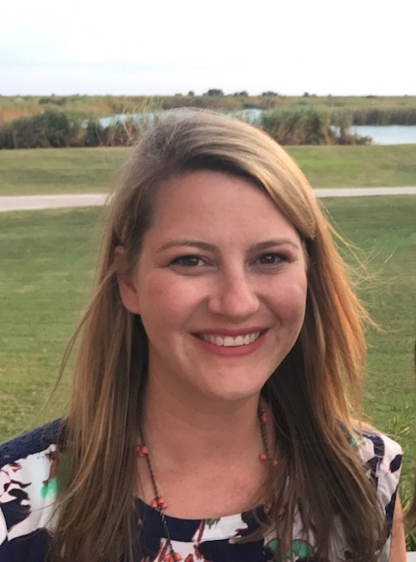**Kate Magsamen**

**Topic: Creating a Budget, Fundraising & Cash Flow; Call Time**

Kate Magsamen is a seasoned political fundraising consultant who has worked in Democratic politics for 15 years. Currently the President of KMM Consulting LLC, Kate works with state, local, federal campaigns and major political action committees that support Democratic candidates. During the 2016 election cycle, Kate served as the Deputy Finance Director for Senate Majority PAC and as well as New York Co-Director for Hillary for America. Prior election cycles, Kate served as Finance Director for U.S. Senators Mary Landrieu, Chris Coons and Chris Dodd as well as Governor Martin O'Malley. Kate is also a Co- Founder, Board & Advisory Council member of Emerge Louisiana, an organization that recruits and trains Democratic women to run for office and win.



**Irene Shin**

**Topic: Digital Ads & Fundraising**

Irene Shin is the Political Director for Crowdpac. Irene is an experienced political operative and fundraiser. She has worked for an array of campaigns and has raised millions of dollars for candidates, national political committees, and political action funds including Senator Kamala Harris and the Democratic Legislative Campaign Committee. She also serves as the Political Advisor for One Vote at a Time, and on the boards of the Competitive Commonwealth Fund and Virginia Civic Engagement Table. She holds a BA in political science from the University of California, Riverside.